1. Use Naïve Bayes to find out given a Red, Domestic , SUV if it is stolen or not? [10 marks]

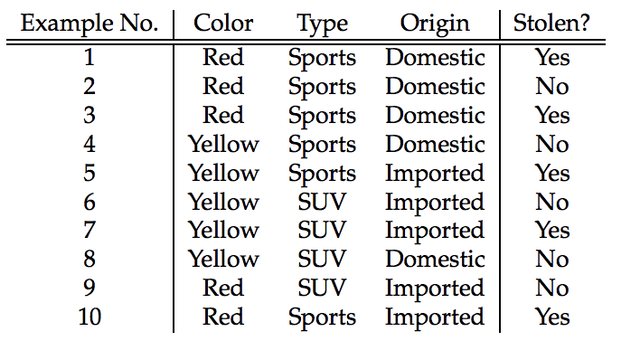

1. Explain the steps involved in implementing a KMeans classifier ? What is the major use of this classifier? What are its weaknesses? [6 marks]
2. According to a national survey, the price of a new family home averages $115,000. One home owner thinks that in his city, the average price exceeds the national average. He records the prices of 20 new homes in his city and find the sample mean to equal $120,000 with a sample standard deviation of $30,000. If α =.05, does the data support his belief? What would be the result if the sample was 100 homes with the same mean and standard deviation above? [In the absence of a table, assume a value ‘a’ from the table and explain your conclusion based on the ‘a’ value] [9 marks]